

**BCA Third Year**

**Semester : VI**

**Title of Project**

**Reworn-revival :- The Clothes Rental Application**

Gunjan Rajgire- 20210801091

Devyani Bhosale- 20210801064

Sakshi Kalaskar- 20210801028

**Entity Relationship Diagram**

This is an ER model of a clothes Rental Application. The entities are represented in rectangular boxes and relationships between different entities are represented by a diamond shaped box.

Here is the ER Diagram.

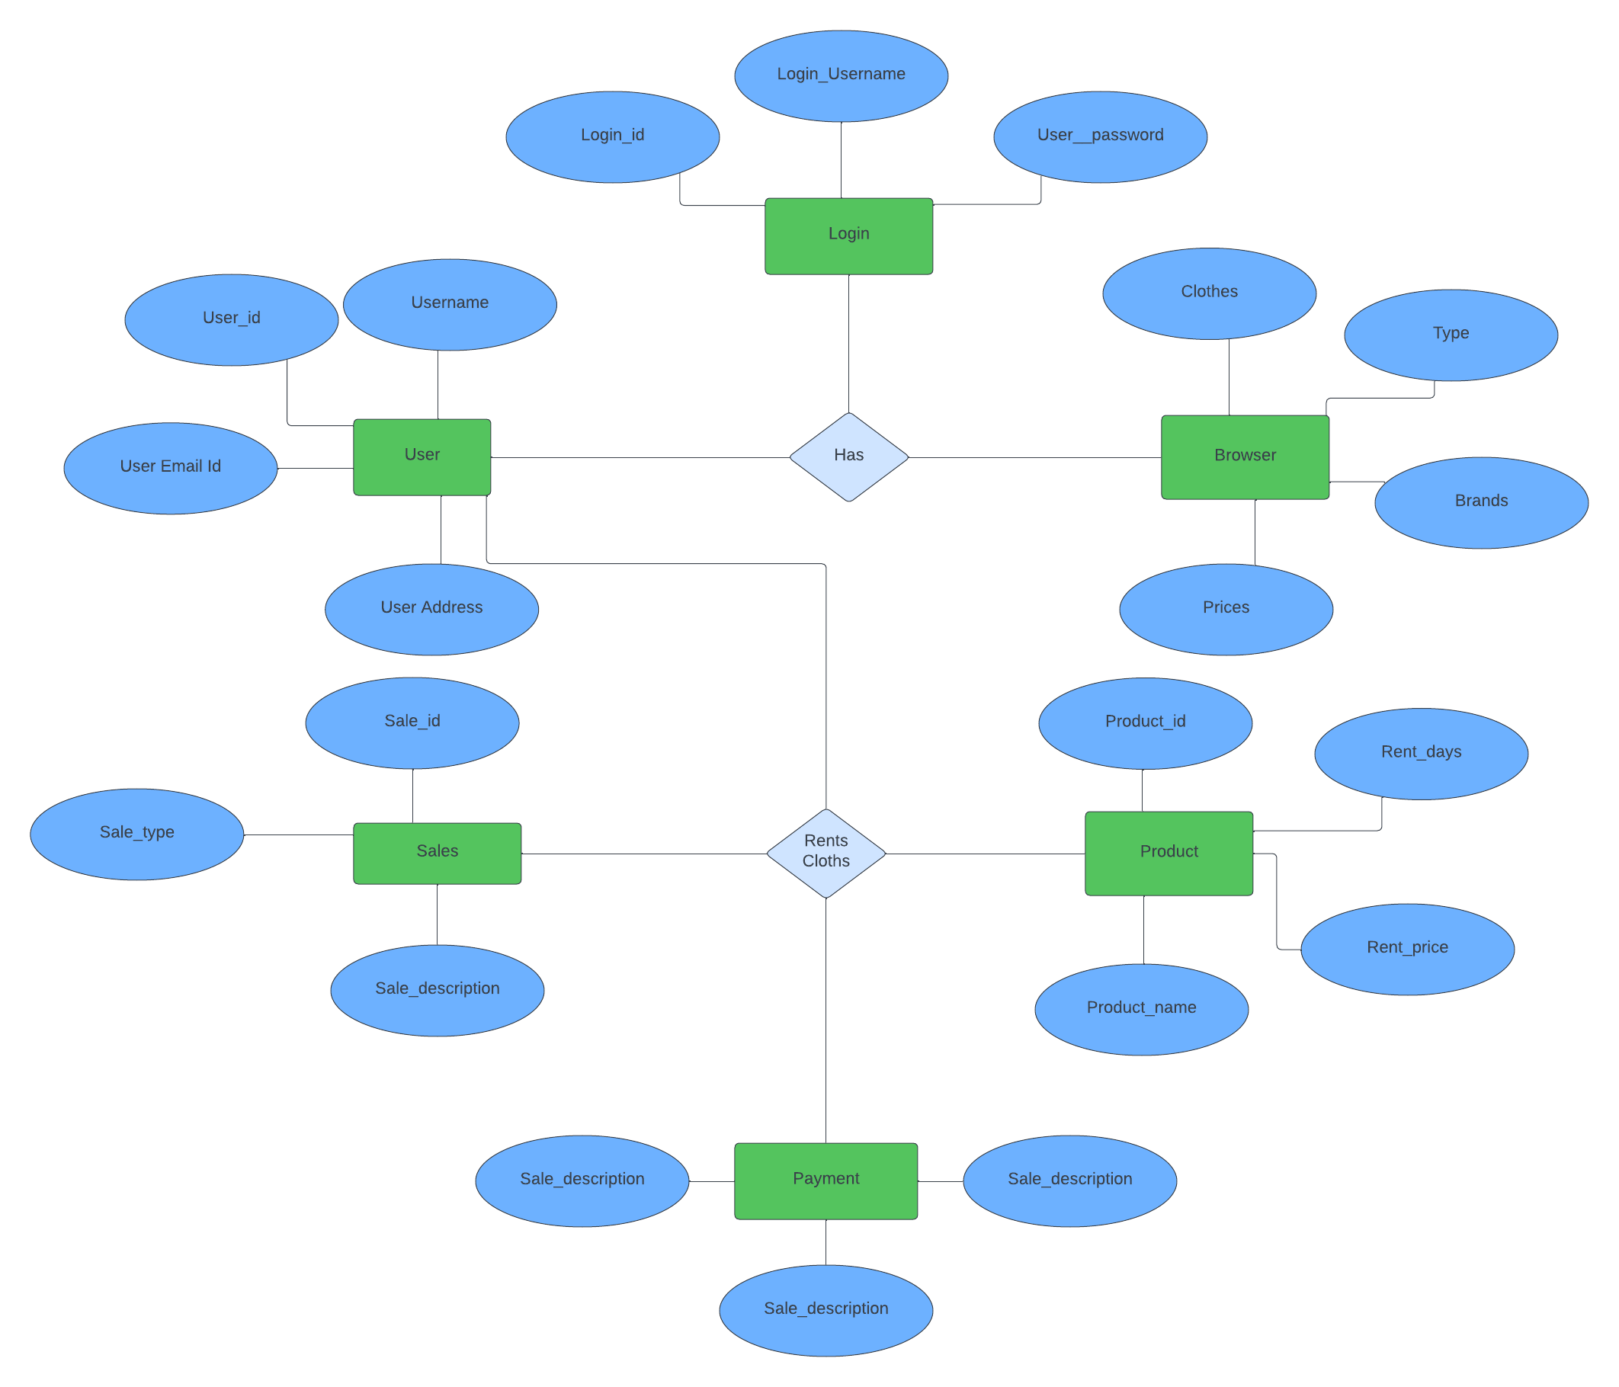

**Data flow Diagram (DFD)**

**Level 1 DFD :**

The first DFD of Clothes Rental Application shows more details of processing. Level 1 DFD list all the major sub processes that makes the entire system.

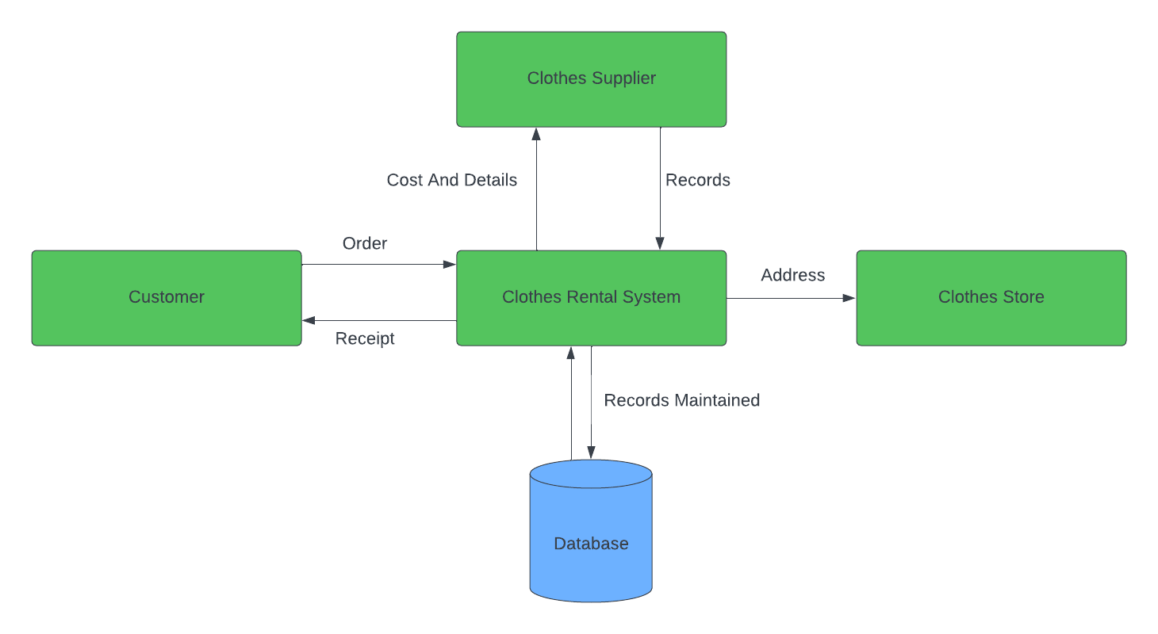

**Level 2 DFD :**

Level 2 DFD for Clothes Rental application dives even deeper into the concept of Level 1 DFD.

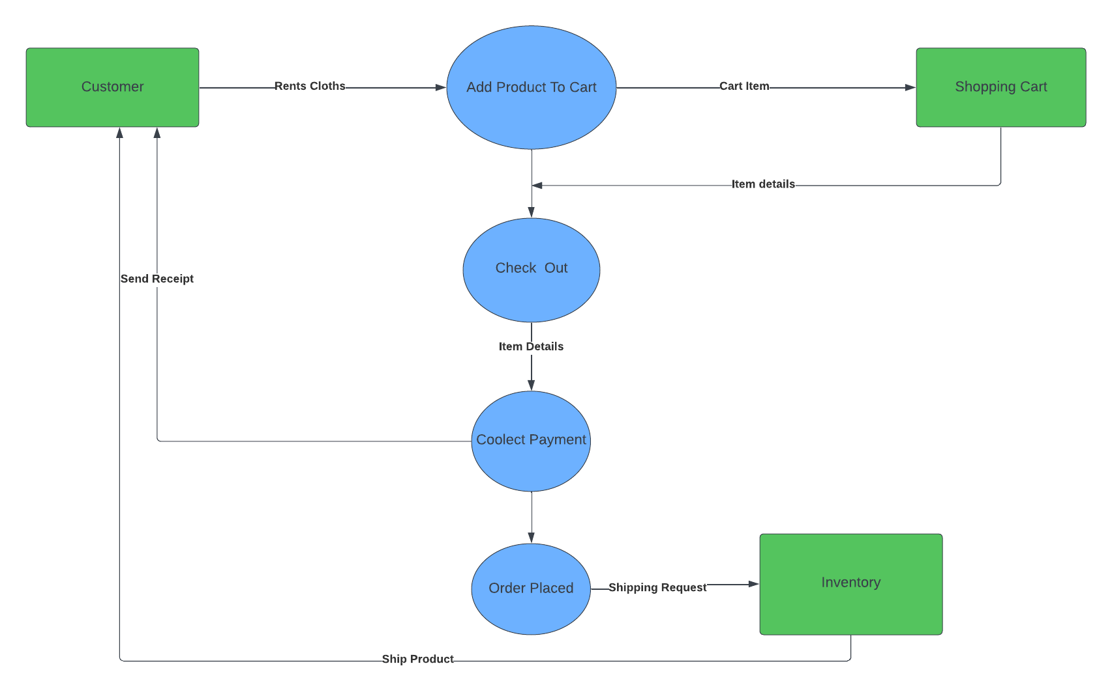

**Flowchart**

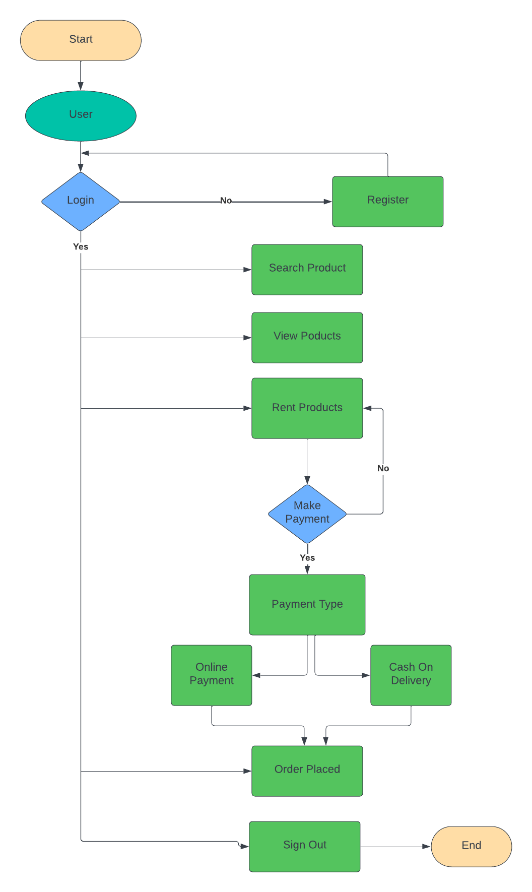A flowchart is a visual representation of a process or algorithm. It is used to describe the sequence of steps and decisions required to perform a task.

**Class Diagram**

a class diagram in the Unified Modeling Language (UML) is a type of static structure diagram that describes the structure of a system by showing the system's classes, their attributes, operations (or methods), and the relationships among objects.

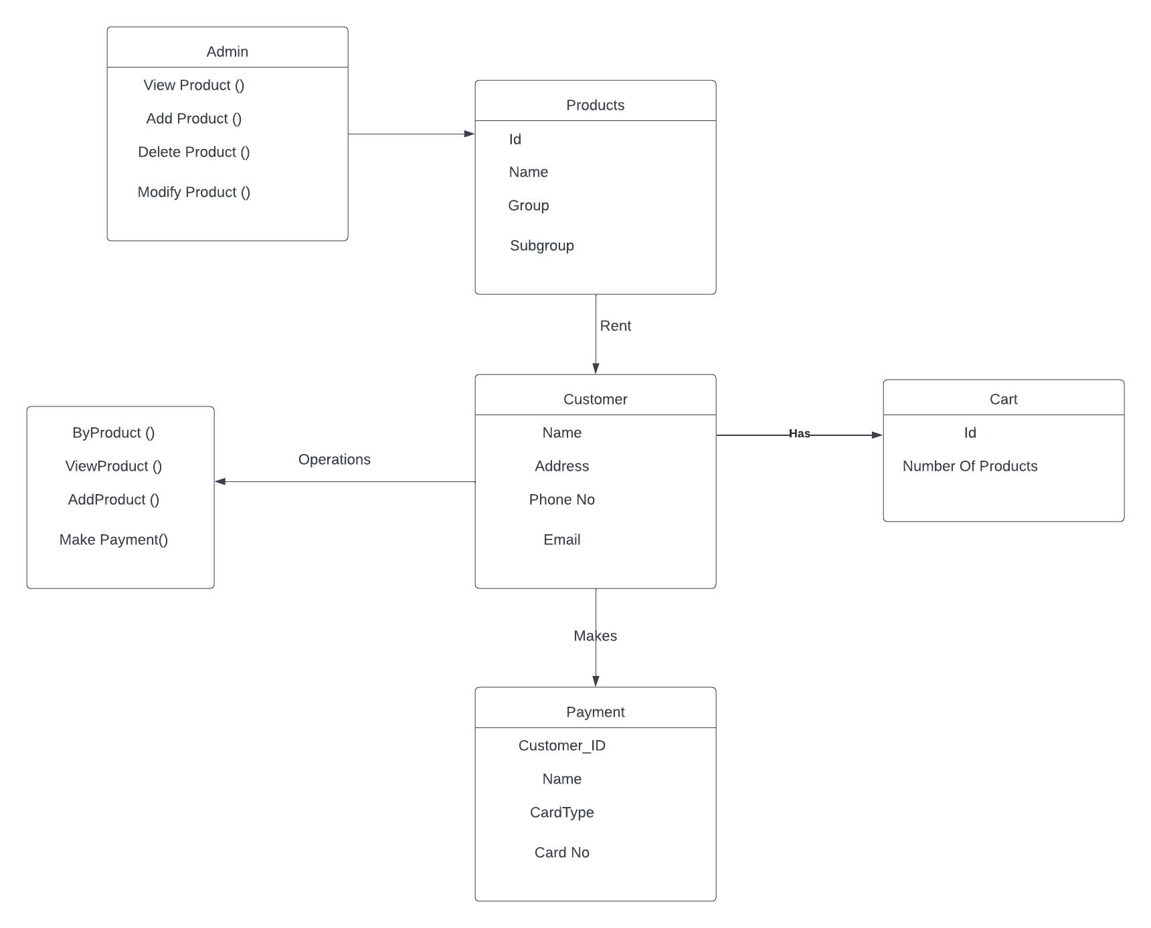

**Pseudocode**

* Pseudocode for Clothes Rental System

# Clothes Rental System Functions for Customers

function login(userCredentials):

# Authenticate the user using MongoDB

if authenticationSuccessful:

currentUser = getUserInfo(userCredentials)

showHomePage()

else:

showErrorMessage()

function logout():

# User logged out

function getUserInfo(userCredentials):

# Retrieve user information from Database

# Home Page Functions

function showHomePage():

listofitem()

else:

error

# Rental Functions

function rentClothes(clothes):

# Rent clothes for the user

if rentalSuccessful:

showHomePage()

else:

showErrorMessage()

function returnClothes(rentalID):

# Return rented clothes

if returnSuccessful:

showHomePage()

else:

showErrorMessage()

//imaginary function

# Payment Mode Function

function makePayment(amount, paymentMethod):

# Process payment for rented clothes

if paymentMethod == "credit_card":

processCreditCardPayment(amount)

elif paymentMethod == "paypal":

processPayPalPayment(amount)

else:

showErrorMessage()

function processCreditCardPayment(amount):

# Process credit card payment

if paymentSuccessful:

return True

else:

return False

function processPayPalPayment(amount):

# Process PayPal payment

if paymentSuccessful:

return True

else:

return False

# Profile Page Functions

function viewProfile(user):

displayUserProfile(user)

function displayUserProfile(user):

# Display user's profile information

# Main Application

function main():

if userIsLoggedIn():

showHomePage()

else:

promptUserToLogIn()

main()

// Pseudo Code For Admin

g # Admin Functions

function adminLogin(adminCredentials):

# Authenticate the admin using MongoDB

if authenticationSuccessful:

showAdminDashboard()

else:

showAdminErrorMessage()

function showAdminDashboard():

# Display admin dashboard with options for managing items and managing payment

# such as adding, deleting, or updating items

function addNewItem(itemDetails):

# Add a new item to the rental inventory

if addItemSuccessful:

return True

else:

return False

function deleteItem(itemID):

# Delete an item from the rental inventory

if deleteItemSuccessful:

return True

else:

return False

function updateItem(itemID, updatedDetails):

# Update details of an existing item in the rental inventory

if updateItemSuccessful:

return True

else:

return False

function payment(user):

# manage payment done by the User

# Main Application

function main():

if userIsLoggedIn():

showHomePage()

else:

promptUserToLogIn()

main()